

PROPOSED STRUCTURE OF A TERMINAL REPORT SYSTEM FOR ARMED FORCES SENIOR HIGH TECHNICAL
SCHOOL, KUMASI

FINAL SYSTEM ARCHITECTURE & SPECIFICATION
Terminal Report Management System for Ghanaian SHS

I. SYSTEM ARCHITECTURE & USER ROLES
The system uses strict role-based access control (RBAC) with a clear approval workflow to ensure data accuracy, consistency, and security.
- Administrator (School Admin / IT Officer)
  - Permissions: Highest level – full access to all modules and data.
  - Responsibilities:
    - Manage the entire system setup, configuration, backups, and security.
    - Create and manage all user accounts (including adding, editing, deactivating accounts for teachers, HODs, Headteacher, students, and parents/guardians).
    - Assign roles, permissions, subjects, classes, streams, programmes, and tracks to users.
    - Perform bulk import/export of staff and student data.
    - Link parent/guardian accounts to their ward(s).
    - Create and manage academic years, terms, double-track (A/B) calendars, school structure, grading scales, comment banks, and report templates.
    - Generate school-wide analytics, audit logs, and reports for management or GES requirements.
    - Troubleshoot issues and maintain system integrity.
- Head of Department (HOD)
  - Permissions: Access to all classes and teachers within their department.
  - Responsibilities:
    - Review and verify subject grades, scores, and comments entered by teachers in their department.
    - Ensure consistency in grading and assessment across teachers in the same subject.
    - Add departmental-level comments if required.
    - Approve reports for their department before final submission.
- Class Teacher / Form Teacher
  - Permissions: Access to data for their assigned class(es).
  - Responsibilities:
    - Oversee the overall report for each student in their class.
    - Input or select general conduct, attendance, attitude, interest/effort, and class teacher’s remarks.
    - Coordinate with subject teachers to ensure timely data entry.
    - Perform first-level review of the completed class report.
- Subject Teacher
  - Permissions: Access only to the students they teach in the subjects they handle.
  - Responsibilities:
    - Enter Continuous Assessment (Class Score), Exam Score, projects, and other assessment components.
    - The system automatically calculates totals, terminal grades, and letter grades based on predefined weightings.
    - Select from comment bank or write personalized subject-specific comments.
    - View class average and position for their subject.
- Student
  - Permissions: Read-only access to their own published reports.
  - Responsibilities: View, print, or download reports in PDF format.
- Parent/Guardian
  - Permissions: Read-only access to their ward’s published reports via secure portal.
  - Responsibilities: View reports, receive notifications, print or download PDF.
Cross-Role Features:
- Full audit trail (who changed what and when).
- In-app, email, and SMS notifications for approvals and report readiness.
- Bulk Excel/CSV import support for scores and student data.

II. CORE FUNCTIONAL MODULES
- Student Information Management
  - Centralized database with: Student ID, Name, Photo, Gender, Date of Birth, Programme, Class/Stream, Track (A/B), Boarding/Day status, Guardian details, Medical information.
  - Support for automatic student promotion at the end of the academic year (with repeat/transfer options).
  - Automatic tagging by Track and Programme.
- Academic Structure Management
  - Track Management: Full support for double-track system (Track A/B).
  - Class & Stream Setup: e.g., Form 2 Science A, Form 3 Arts B.
  - Subject Management:
    - Core Subjects (English, Core Mathematics, Integrated Science, Social Studies, etc.).
    - Elective Subjects grouped by programme (Science, General Arts, Business, Visual Arts, Home Economics, Agriculture, Technical, etc.).
    - Automatic separation of Core and Elective sections on reports.
    - Easy assignment of subjects to departments and teachers.
- Assessment & Grading Module
  - Grading Scale Configuration: Flexible support for numerical (1–100) and WASSCE-style grades: A1 (80–100), B2 (75–79), B3 (70–74), C4–C6 (55–69), D7–E8 (40–54), F9 (0–39).
  - Assessment Weighting: Configurable per subject (e.g., Class Score 30% + Exam 70%, or 50/50). Support for projects and practicals.
  - Score Input: Clean interface with auto-calculation of:
    - Total Score
    - Grade
    - Position in Subject
    - Position in Class
    - Class Average
  - Comment Bank: Pre-approved comments for academics, effort, behaviour, conduct, attitude, and interest. Option for personalized text.
- Report Generation & Templating Engine
  - Customizable templates by form level (simpler for Form 1, detailed for Form 3).
  - Support for single-term and cumulative (Term 1–3) reports.
  - Standard Report Sections (Ghana SHS style):
    - School header with logo, academic year, term, and next term reopening date.
    - Student details including photo, class, programme, track, and boarding status.
    - Core Subjects table: Subject | Class Score | Exam Score | Total | Position | Grade | Remarks.
    - Elective Subjects table (same columns).
    - Overall Average, Class Position, and Class Average.
    - Attendance (Days Present / Total).
    - Affective Domain: Conduct, Attitude, Interest/Effort.
    - Class Teacher’s Remarks + Signature.
    - Headteacher’s Remarks + Signature.
    - Promotion Status.
  - Output Formats: Print-ready PDF + web view for portal.
- Communication Portal
  - SMS notifications to parents with brief results summary.
  - Secure Parent/Student Portal for viewing and downloading reports.
  - Notifications when reports are ready or require approval.
- Analytics & Reporting (For Management)
  - Dashboards showing class averages, subject performance, pass/fail rates, top performers, and trends by programme, track, or gender.
  - Exportable reports for school management and GES.

III. TECHNICAL CONSIDERATIONS
- Platform: Fully web-based, responsive design (works well on computers, tablets, and mobiles).
- Hosting: Cloud-based for reliability and easy access from anywhere.
- Security: HTTPS encryption, strong password policies, role-based access control, and data encryption for student records.
- Data Backup: Automated daily backups.
- Additional Recommendations:
  - Support for offline/progressive web app mode (for unstable internet).
  - Bulk Excel import/export for scores and student data.
  - Mobile-friendly score entry interface for teachers.

1. MASTER SYSTEM FLOW (END-TO-END)

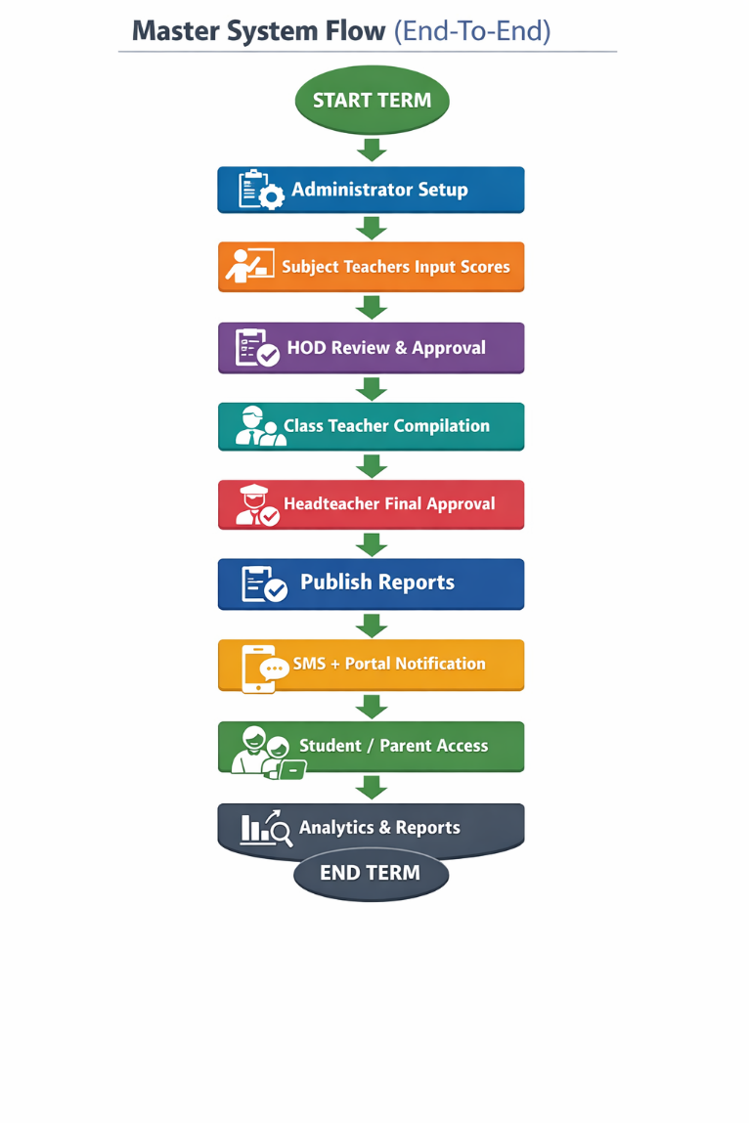

2. ROLE-BASED ACCESS FLOW (RBAC MODEL)

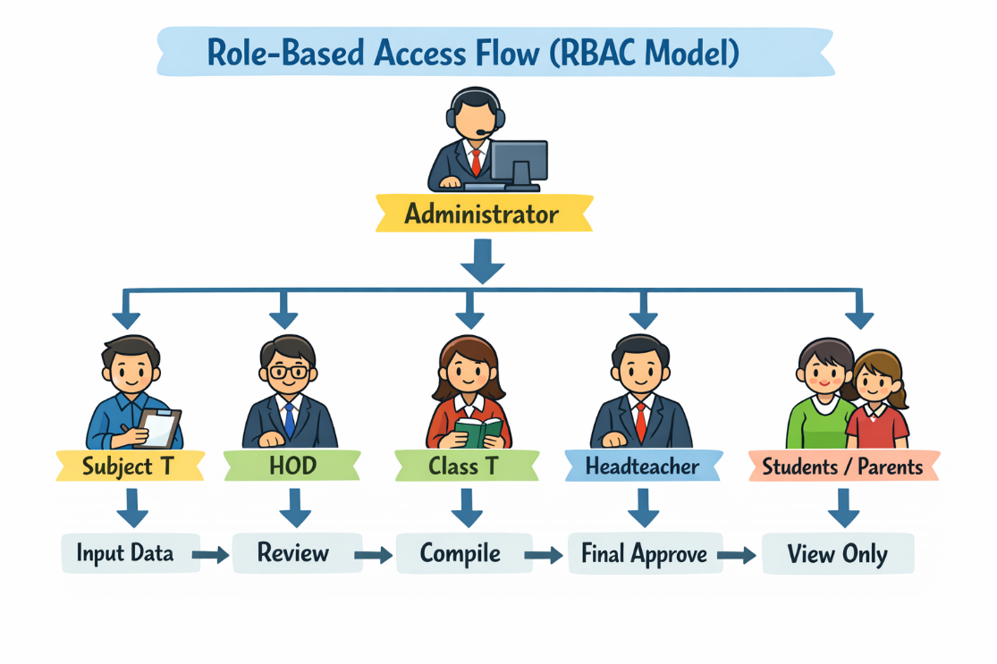

3. ADMINISTRATOR WORKFLOW
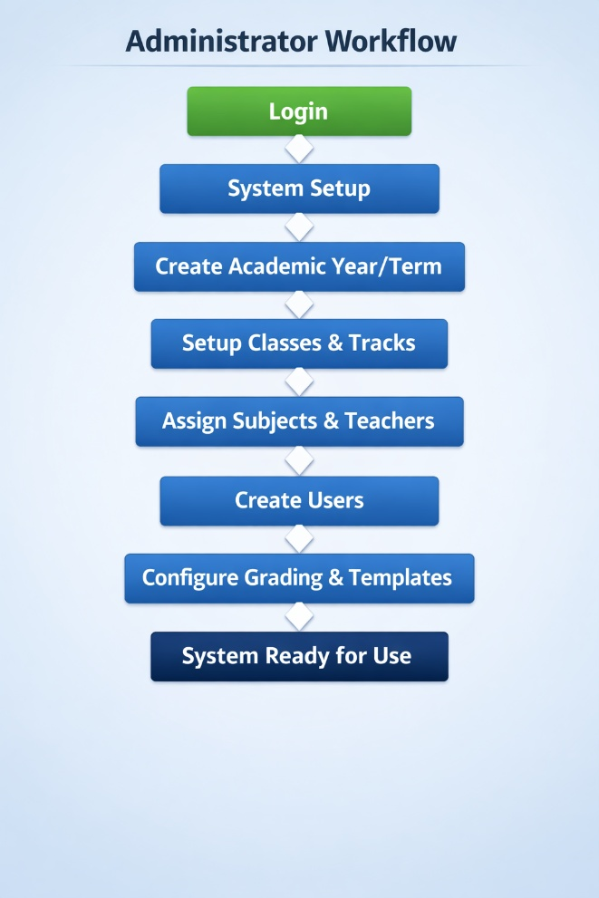

4. SUBJECT TEACHER FLOW
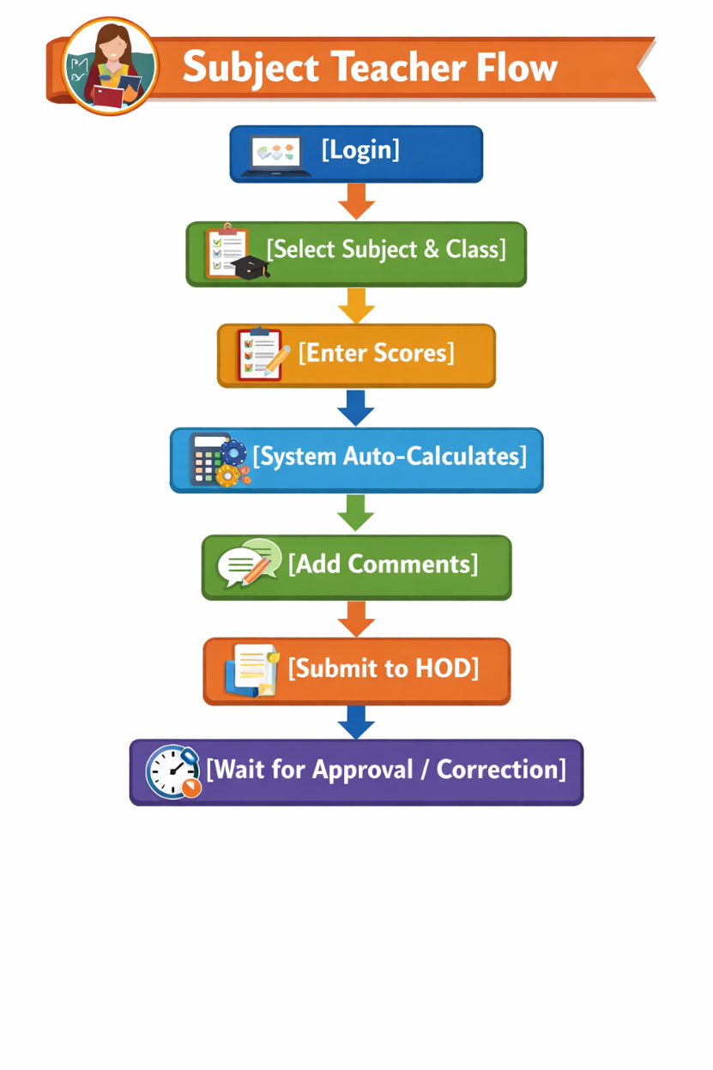

5. HOD REVIEW FLOW
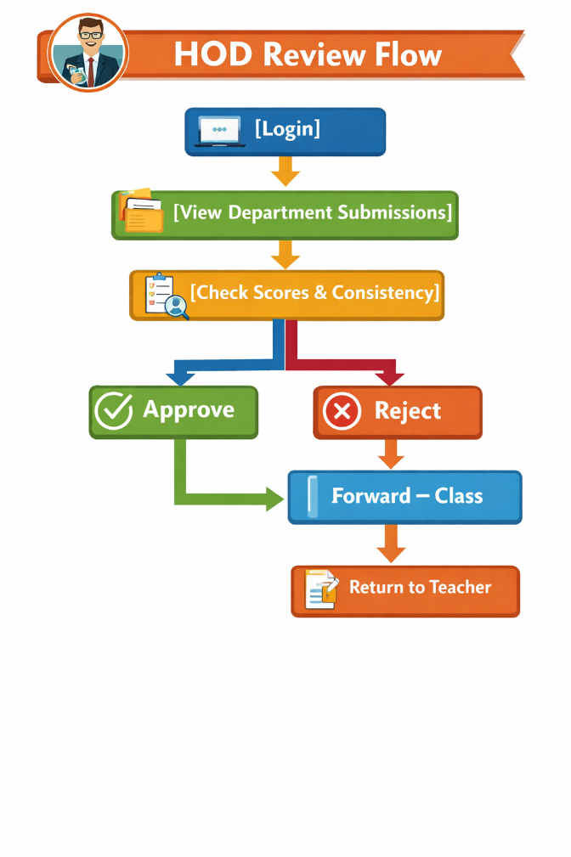

CLASS TEACHER FLOW
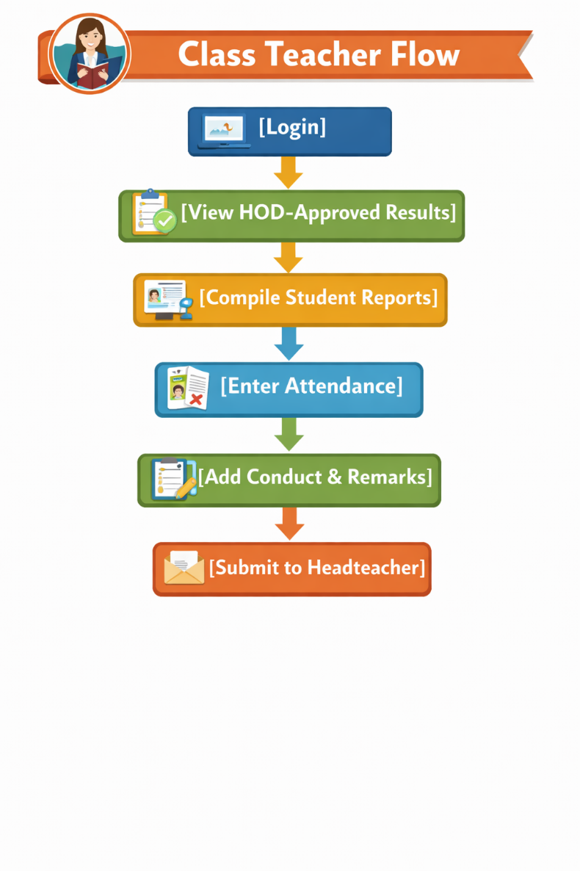

HEADTEACHER FLOW

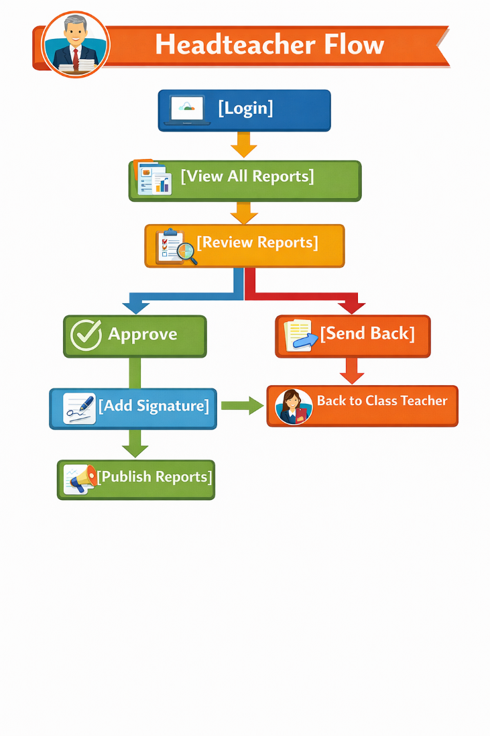

STUDENT ACCESS FLOW
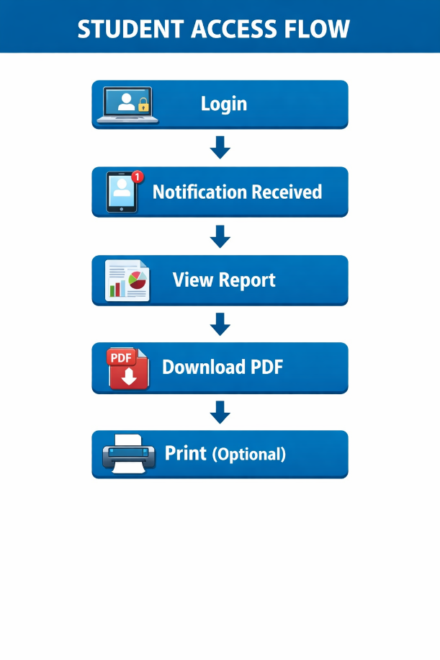

PARENT/GUARDIAN FLOW
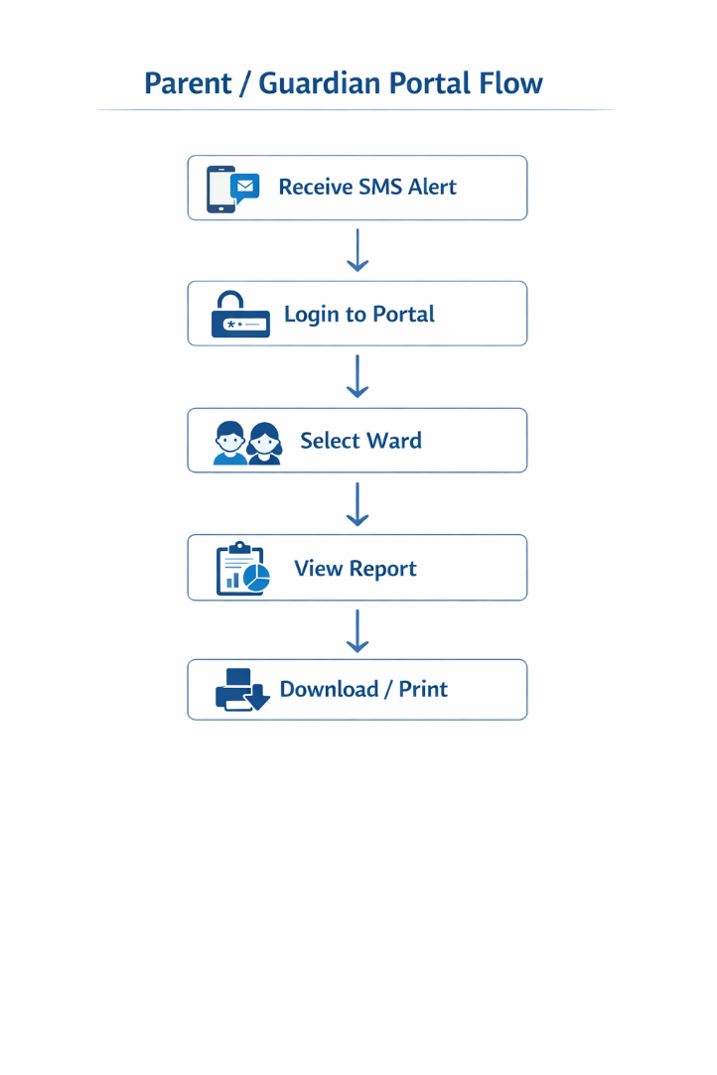

10. DATA FLOW (CORE ENGINE)
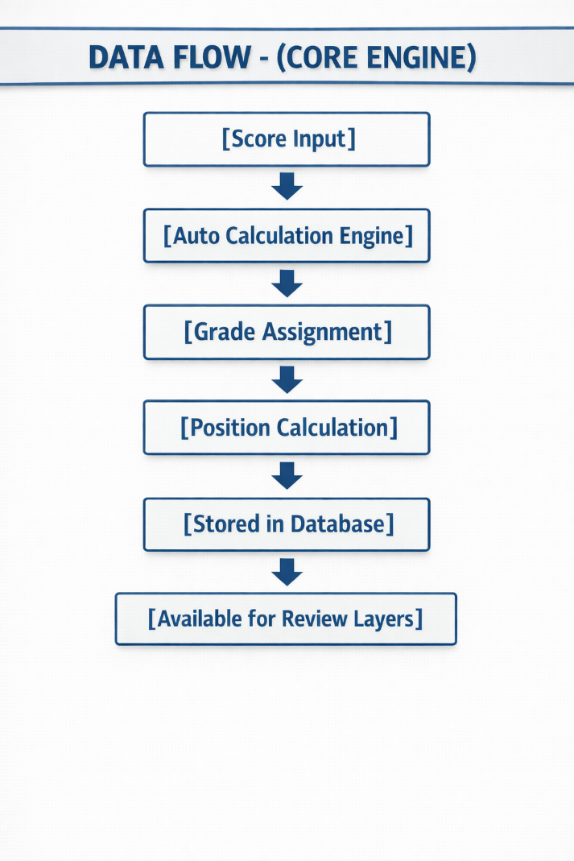

WEBSITE STRUCTURE & CORE PAGES
A. Main Website (Public-Facing)
- Homepage: Dynamic slider with key announcements, quick links, school motto, and highlights.
- About Us:
  - History
  - Mission, Vision, and Core Values
  - School Administration (Headteacher, Board of Governors etc.)
  - School Anthem
- Academics:
  - Programs Offered (e.g., Sciences, Business, Technical, Arts)
  - Departmental Information (HODs, Course Details)
  - School Calendar (Academic Year, Term Dates)
- Admissions (Freshers):
  - Public View: Admission Requirements, Prospectus (PDF Download), Fee Structure etc..
  - Private Portal: Link to the Online Admission Portal (see Section II).
- Student Life:
  - Events & Galleries
  - Achievements (Sports, Academics, Competitions)
  - Clubs & Societies
- Staff Life: For teaching and non-teaching staff (biographies and contacts).
- Alumni Section:
  - Alumni News and Events
  - Alumni Registration Form
  - Success Stories
- News & Blog: For articles, announcements, and updates.
- Contact Us: Location map, phone numbers, email addresses, and a contact form.
B. Secure User Portals (Require Login)
- Admission Applicant Portal: For freshers to complete registration.
- Student Portal: For current students (access to documents,).
- Admin Portal: For staff to manage website content and process requests.

II. Core Functional Modules
1. Content Management System (CMS)
- Purpose: To allow school staff (e.g., Admin ) to easily update website content
- Features: Easy text/image editing, event calendar management, photo gallery uploads, news article publishing.
2. Online Admission Portal (For Freshers)
- Functionality:
  - Online Application Form: Captures student bio-data, parent/guardian info, academic history, and program choice.
  - Payment Integration: Integration with mobile money (e.g., MTN, Telecel) and/or bank payment gateways for registration fees.
    - Generates a unique transaction ID.
    - Automatically updates application status to "Payment Verified" upon successful payment.
  - Automated Email/SMS Notifications: Sends confirmation upon application submission, payment receipt, and admission status.
  - Downloadable Documents: Successful applicants can log in to download their:
    - Admission Letter
    - Prospectus
    - others
3. Document Request System (E.g., Testimonials etc.)
- Functionality:
  - Secure Login: For current students and alumni.
  - Online Request Form: Select document type (Testimonial etc.), purpose, and delivery method (Pick-up, Email).
  - Status Tracking: Applicants can track the progress of their request (e.g., Received, In-Process, Approved, Ready for Pick-Up).
  - Admin Dashboard: School administration can view, process, and manage all requests, mark them as completed, and upload soft copies if needed.
  - Fee Payment (if applicable): Integrated payment for document processing fees.

III. Technical Specifications
- Platform: Modern, responsive design (works perfectly on desktops, tablets, and phones).
- Technology: Built on a robust framework for security and scalability.
- Security:
  - SSL Certificate (HTTPS) for secure data transmission.
  - Strong password policies for user accounts.
  - Regular security updates and backups.
- Hosting: Reliable cloud hosting with high uptime.

